SEN Plan

Profile; 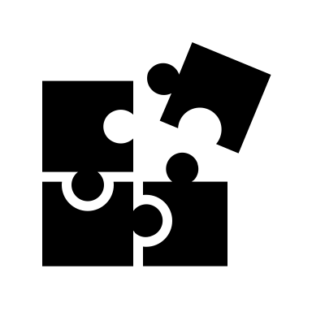

Age: 18 to 19 years old

Class size: approx 15

Class duration: 1 hour

SEN: Various disabilities eg. Autism, Down Syndrome

Main idea: Puzzles and me, myself and I

Themes;

Themes: Puzzles/ Jigsaws and me, myself and I

Family tree

My home

Activities;

Blind drawings ; mirrors

Tye-Dye ; colour

Collagraph ; Blind drawings

Personal Collage

making a magazine or book

Roles/who’s doing what;

Aoibheann; Blind drawing

Dáire; Collagraph, mono print

Louis; Tye-Dye

Eimear; Personal Piece

PLAN

lesson 1: detailed

intro, blind drawing

lesson 2:

mono print

lesson 3: Detailed

collagraph

Lesson 4:

  continue of Collagraph

lesson 5: Detailed

tye-dye

lesson 6:

discussion day (what they like, interests) peaceful day :)

lesson 7: Detailed

making own inspired collaged puzzle piece

lesson 8:

Hanging pieces up and celebration